CLAUDE QUIZEZ
AUDIOGRAMZ QUIZ
https://claude.ai/public/artifacts/531a6c3f-c972-4598-be52-84c55975eb8a
TYMPNOGRAMZ QUIZ
https://claude.ai/public/artifacts/531a6c3f-c972-4598-be52-84c55975eb8a
COMPLETE AUDIOLOGICAL ASSESSMENTZ
https://htmlpreview.github.io/?https://github.com/ethanheinrick01-ctrl/lsu-audiology-exam-review/blob/main/index.html
All 5 Comprehensive Aud. Assessments she covered in class. Noice.
The PE Tubes one will not be on exam. pwnd.

TEST FORMAT
EXAM 2 QUESTIONZ 4 COMPREHENSIVE AUD ASSESSMENTZ
-70 QUESTIONS TOTAL (CHAPTERS 5-6).
- EXAM QUESTION TYPES WILL INCLUDE:
-MC / TF Questions - NO WRITTEN
-3 tymps on exam
1 comprehensive audiological assessment on exam
“THE LEARNING OUTCOME SLIDE AT THE BEGINNING OF THE POWERPOINT SLIDES TELLS YOU WHAT YOU SHOULD KNOW”
-Know norms for tymp / pure tone / speech “they will not be on the test”
- “i wont put tricky ones on the test” (talking about the comprehensive audiological assessment)
Pure Tone:
- interpret puretone (5 things)
-Calculate PTA -(TEST QUESTION) - Look at speech audio - is there a good or bad agreement between STR and PTA
-(TEST QUESTION) - What sensation level was used? (level presented minus speech threshold)...And the degree of difficulty
- sensation level used?
Tymp Graph:
- find Peak compliance / peak pressure / EC volume - is it normal ?
-find the type
-what could it indicate? (type c = eustachian tube disfunction)
- “ you won't have to calculate Tymp Width, but there will be questions about TM width on test”
-type B causes HL
Acoustic reflexes:
-Calculate sensation levels IPSI Right and Left (HL minus PTA)
-Is it reduced , elevated , or normal ? (know the ranges)
- Know shit like the only one of these 3 that causes reduced HL is cochlear loss

COMP. AUD. ASSSEZ
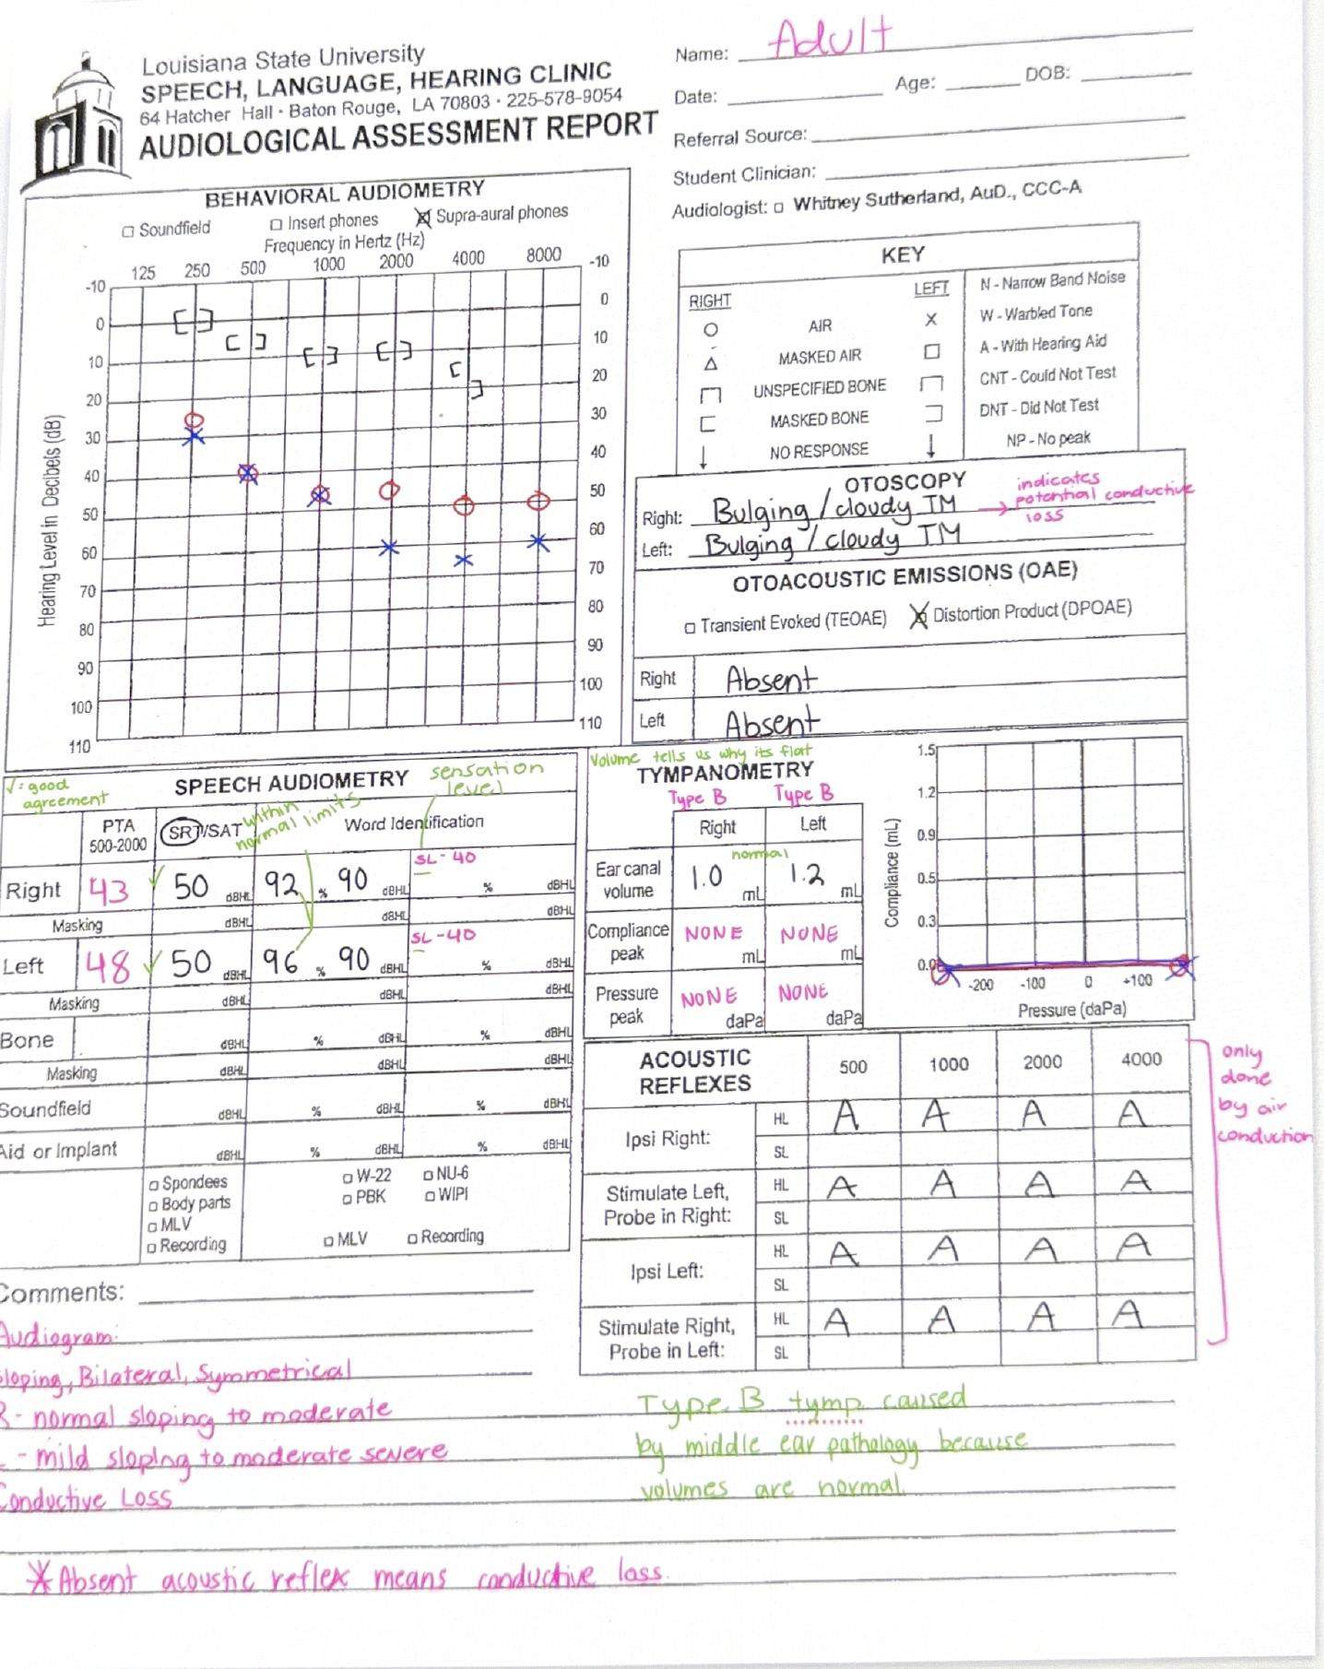
BLACK TEXT = WHAT WAS GIVEN
PINK TEXT = WHAT WELL HAVE TO FILL OUT
GREEN TEXT = NOTEZ
PROFESSOR EXPLAINING - read how my professor explained this audiological assessment to the class and her way of thinking and what she expects in what she ought to put on the exam. This is like gold.
“Here again this way further, Okay, so 1st thing I want you all to look at. Is a toss of these instruments? Okay? What did I tell you is going on? When I look at the ears, I don't see anything in the air canal, but when I stare down that tunnel and look at the tempanic memory, I see that the tubanic memory is bulging, meaning it is bulging out into the air now. Like there's something inside of it. And then cloudy. I could say, you know, red is, I could say, you know, air bubbles, but I say cloudy, indicating that there is something in that middle ear that is making that to give memory bold and gives it this cloudy appearance instead of the semi-transparent that I would propose. Okay, so in my mind, I'm hypothesizing what I think that is. But What does it make you think as far as hearing loss? Are you expecting to see a certain type of urine loss when you see something going on in the middle year? Conductive, right? Or maybe mix because I might have a cent hero, but I'm gonna have some type of conductor compon. Okay? So then we do the pure tone test. And do I have a hearing loss? Yes. One or two? Is it symmetric? I'd say so. Okay? the Exactly. You've got a little bit of an acemicry with high frequencies, but it's not putting in a row, right? I need some real patients that I picked off and wrote down to show you, that sounds perfect. Somebody asked me on the test, is it gonna be multiple choice, true false questions? Yes. I'm gonna give you one of these, but you're gonna have options. Okay?. So, it's going to be... Sybil, yeah. Similar like All right, so I'm just going to. What is my configuration? Okay, what type of hearing loss do I have? No. Definitely a go? Yes. Because, if I look at all my balance reductions, they're anywhere from 0 to 20, that's normal. So my bone is normal, my hair is impaired, yermo gas, conductor loss. So this, and this makes sense together, right? So now, OAE. I did DPOAE. And they were absent. And so a distortion product Od acoustic emission can be accent with what? Smile, even all the way up to moderate hearing losses. So this makes sense. This makes sense that I would have accent reflexes, right? So so far everything is working in my favor. It all making sense. So, a couple things can cause a conductor hearing loss. So it can be an obstruction that's in the outer ear. It could be something in the middle, either. Do I think it's out or middle ear? middle. Middle. Middle. Because I looked in the here I' in the ear canal, but I'm digging middle. Okay? So then let's just look at tionograpry. All right, so, This is an adult. Are those volumes good or bad? Wait, I heard something. What does somebody say? Are they normal or not? Does anybody think they're not normal? Good. Th are normal ear gonna have vibes for an adult. If you look at my tin, what kind of tip do I have? B, B was bad, right? I have a flat tip, but I need to know the volume, because the volume tells me why it's flat. So remember, I said, if you get a really, really gigantic volume, like 4.0, 5.0, 6.0. Why could I get a flat team with a really big volume? corporation. And if I got to type in that tip with a very, very tiny volume and say point 2 for the adult. I think out of your instructions. So I can rule both of those out. What's causing my type B temp? Middle ear pathology, so far, this makes sense with this, and with this, and with this, everything fits together like a puzzle. Yes. So if it says cloudy TM, is it kind of mean that you're gonna have a type B, like something? For me, that's what I'm always assuming. I'm looking at the ear. I'm like, I can't say it's fluid for sure, but I'm pretty sure and seeing some really funny discharge in the fail ear. That white kind of milky fluted, pushing on the ear and pushing out. Okay, so, now, he's looking at our speech, okay? So, our Puretone averages, who calculated it for the radio? 40 is it? 43.3. Do I have good Freeman? Yes. What is it for the left? 48.3? Do you have good agreement? also yes. Word identification. Words were presented at 90, but my patient has a hearing loss, right now? At baseline, your speech threshold is a moderate loss. So what does 98 sound like to them? Or meaning what is the sensation level? Totally. 4 years. Because I said what was the sensation level used? 90-50 is 40. What does that mean again? Well, that means that if that's 90B sound, this 90B word is that patients sound like 40? right? And with that, how do they do? 92%, 96%. the normal normal, right? No difficulty. So, this makes sense because I know in purely connected losses, that inner ear is fine. If I can get the sound loud enough, they hear it as mortarizing fears. So I'm not gonna ask you that on the test. know, what does that mean? But I know, well, I see that all the time with conducting losses. There's really good organ intelligibility scores because the interview is the end, right? It's just a loss of volume. Lastly, our acoustic reflexes. They are all absent. Okay? So, I remember telling you all, what can cause an absolute acoustic reflex? Now, I'm not gonna ask you that on the test, because I really told you, the only one I'm gonna ask you, what does it mean for reflexes was reduced sensation. But conducted loss is one of the reasons you'd be in actual reflexes. So think for a 2nd. You're presenting beeps at 90, 100, well, actually, 70, 80, 90, 100, 80. So if I'm presenting it a 100 DBs, loud as I can present the acoustic reflex, 100, to an ear that has thresholds at 40 and 50 and 60, What's the sensational gonna be of that tone? You're going to hear that tone as like a 50 DD tone, 40 DD or so it's not allowed sound to them, is it? Because that came up the bloss and muffles that sound getting into the cole. So you're not going to get an acoustic reflex, but they cannot be lost, because you're not going to have a loud sound raising the book there. and going through that reflex property. Does that make sense? So this is very consistent with this. But do you all feel good enough to question after asking you? They're pretty consistent, right? Everything we're asking doesn't change. Yes, Is itoustic reflex only done by like air and not on. Correct. The acusive reflexes are always, always, always, only done by air condition. Remember that equipment I sent you that picture. We have that insert trace user.”
/Users/ethanheinrick/Library/Containers/com.apple.VoiceMemos/Data/tmp/.com.apple.uikit.itemprovider.temporary.mePw5V/SECOND EXAMPLE.m4a

https://claude.ai/public/artifacts/ba5c9230-2e20-415f-97ab-d55de7349b8c

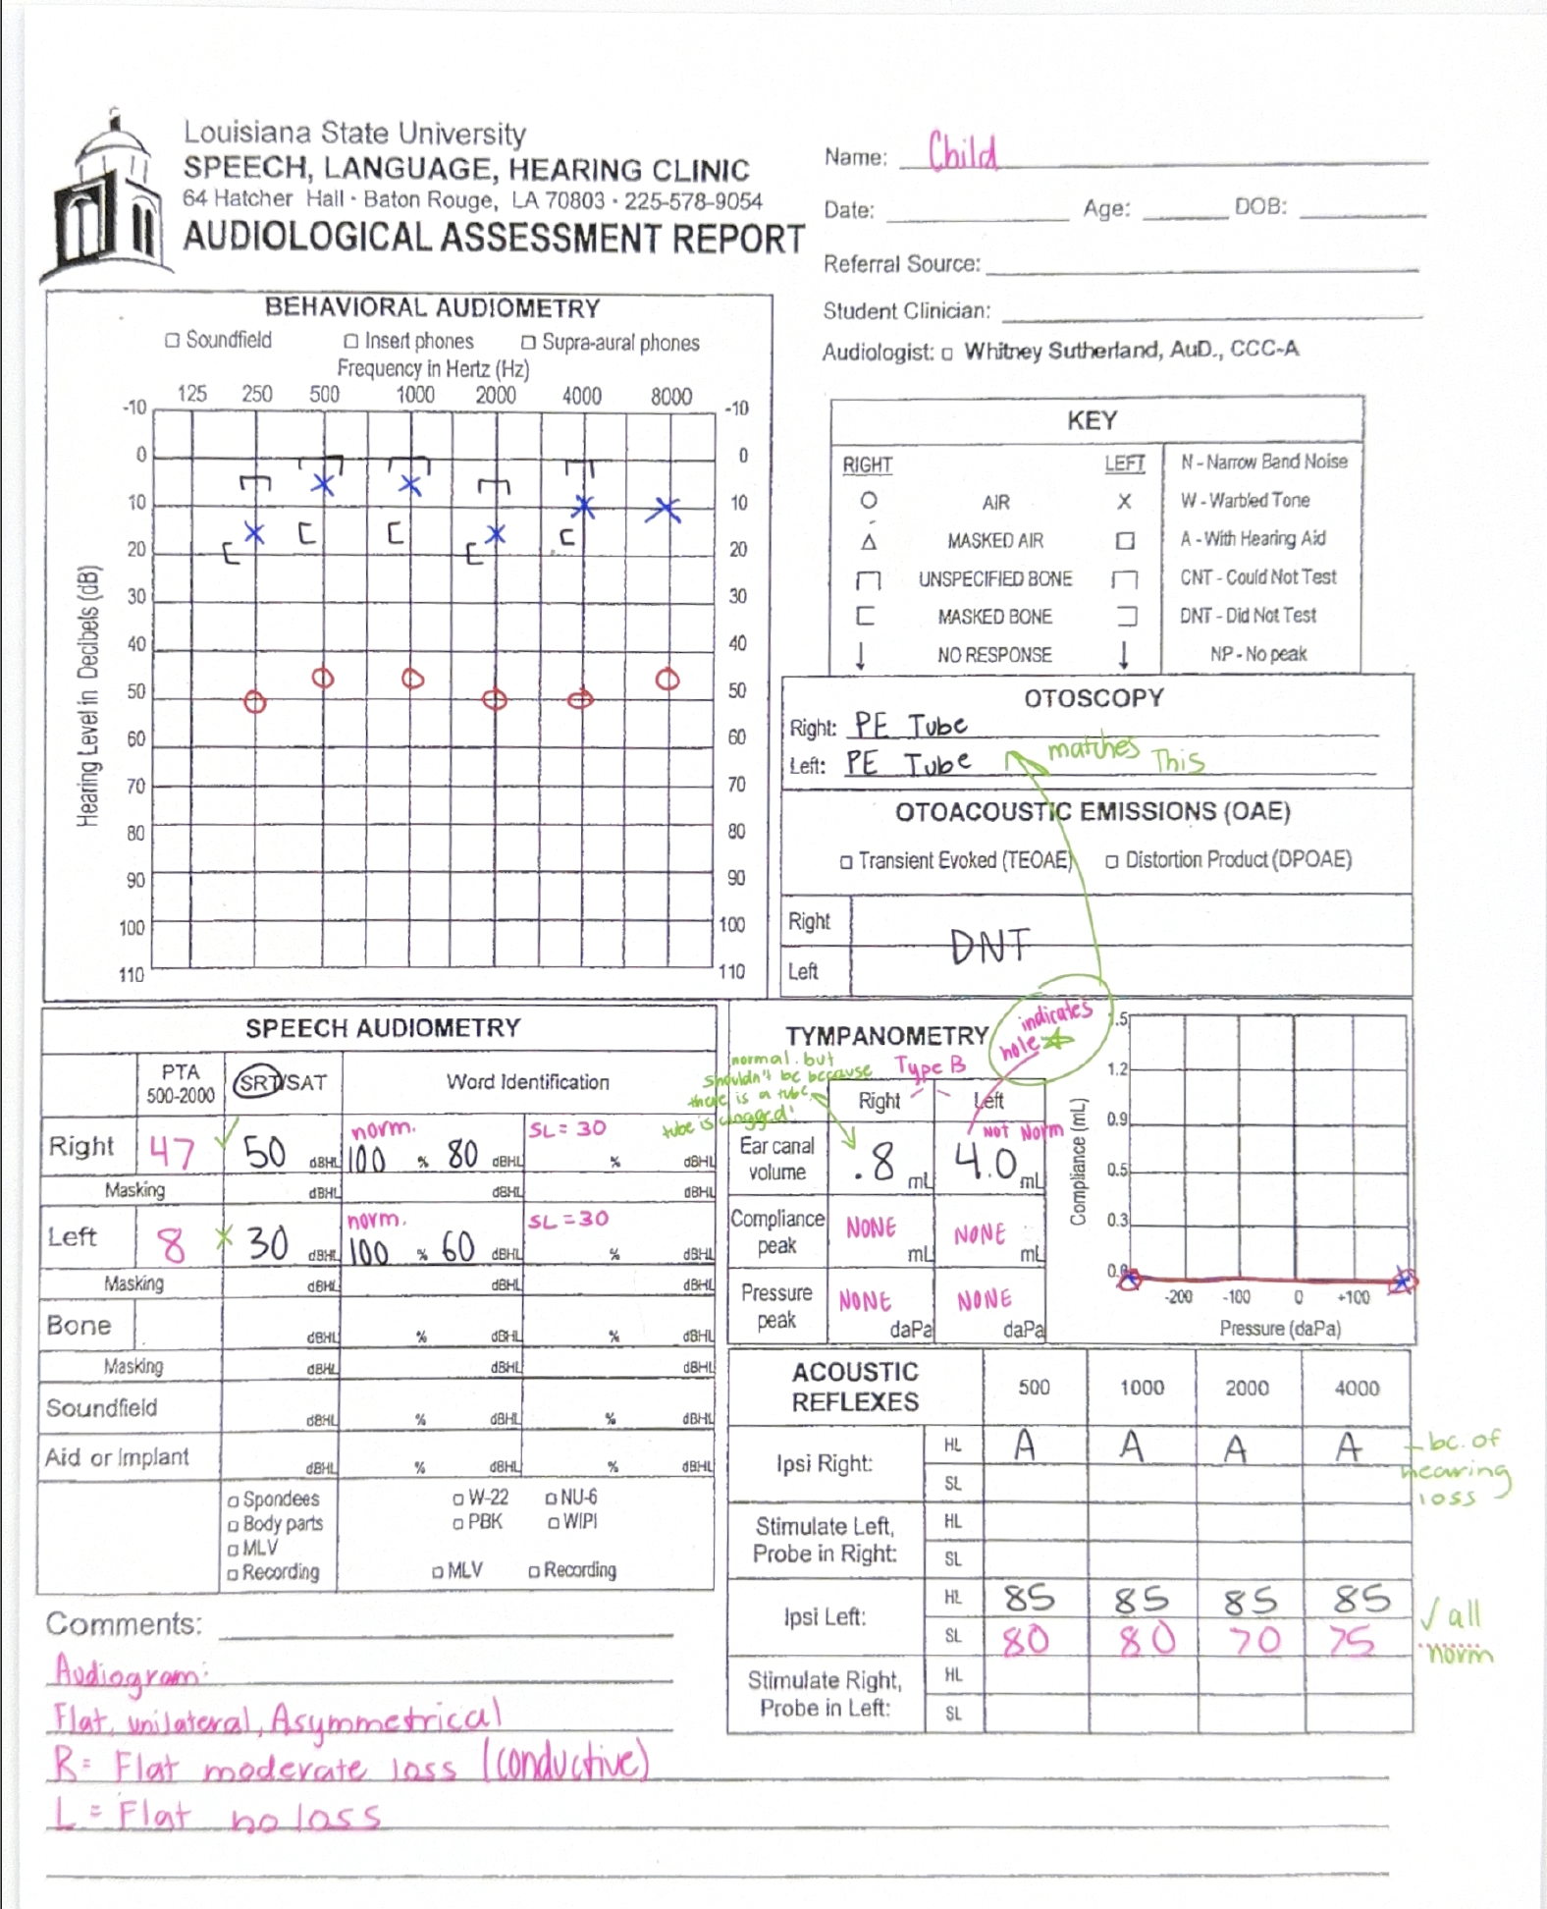
BLACK TEXT = WHAT WAS GIVEN
PINK TEXT = WHAT WELL HAVE TO FILL OUT
GREEN TEXT = NOTEZ
PROFESSOR EXPLAINING - THIS IS TOO COMPLEX FOR EXAM, BUT LISTEN HOW SHE WALK THROUGH THIS
“Let's start where we always. Do I have a few Yes. One of right here. So I had Okay. So unilateral lines. It's the right ear. What is my configuration? Relax. And what type? So I have no hearing loss in my left ear. What type of hairaring loss do I have in my writing ear? What's the deris? Moderate, conductive, flat, urine, loss, and run, right? Everybody agrees. They air is normal bonus app. So you think that could lost. Maybe a lot of reasons we have, right? We don't know you. Let's look at our space or truth. Okay? What were my period averages? Uh.. So 8.3 to the left. Do I have good agreement? No. Okay. Um, this is a child. So all I'm gonna ask you is, am I a good agreement or not? For me, I'm thinking that I have a reinstruct. My child just, you know, maybe he didn't understand the instructions because this could be better, okay? But do I have good agreement here? Yes. Yes, I good agreement between my pure average for the writing. Hey, presentation levels. I presented the words at 60 DDHL on the left here. What's the st level of that. what about for the writing? 30. Also 30. Okay? Our West 4s. Good, okay. and again, finally have condued hearing loss of one ear to conduct your I think that's fine. I wouldn't expect anything unusual there. So far this is all like telling me just conductive loss and the right. Photography told me I have pressure equalization 2s in both peers. Okay? So, This is where it gets a little tricky. Typonometry. What type of tips do I have? B, flat. So I need to look at the volume to figure out why they reflect. So my left ear, the volume is 4.0. Is that a normal volume for a child? No. Okay. What causes a really big volume in high BTS? Oh, which I confer that I have. I have a PE2 to that left ear. okay? Guys, if you have a tube in an ear, you should have normal hearing in that ear because the tube is there to help make sure that we have, you know, good pressure in the middle ear and that fluid doesn't build up. So I'm happy because the left ear's showing a tube, the hearing's normal and it's flat with a giant volume. That's what I would expect. But what about for the right ear. 0.8 is that a normal volume for a child? okay? But should I get a normal volume with the two? No. So what do I think tapping into my tube? The tube is called? Okay? That's why this one. We got put like this test this happens all the time. So this is the kiddo. It has the tube, but this should not be happy. It's a Greeklexes. Pretty consistent with what I'd expect for the leftie, right? I got normal reflexes and if I calculated by sensation levels, they're normal, right? you calculate your sensational almost not yet. But again, like 85 -5 is 80, right? 85 -5, eight, 85-15, 70, 85-10, 75. Those are all normal cedation workers, right? I'd expect that. So right here, my reflexes were active. Well, yeah, because I have it ear in loss, end up with ear in loss, okay? So every day is telling me, this is what I would expect, except my right ear. So I just wanted to show you one word like you can see where something doesn't look right. So 2 things on this didn't look right. This, to me, now on the task again. Don first here, I'm not gonna ask you what does it lookire this on. I'm not gonna give you a list. But I wanted to show you why these all fit together with theosit. something doesn't look right. fix. They're like, this did not look right, but I can't get enough period very average. So me as an audiologist would go, I need to go back and check this again. And then this. 2 when this small volume doesn't look right. So that's something that so your audio grab spells out what you need to fix for why you need to work on. Okay? Everything is pretty black and white on. Any questions about this?”

/Users/ethanheinrick/Library/Containers/com.apple.VoiceMemos/Data/tmp/.com.apple.uikit.itemprovider.temporary.0brK5G/THIRD EXAMPLE.m4a
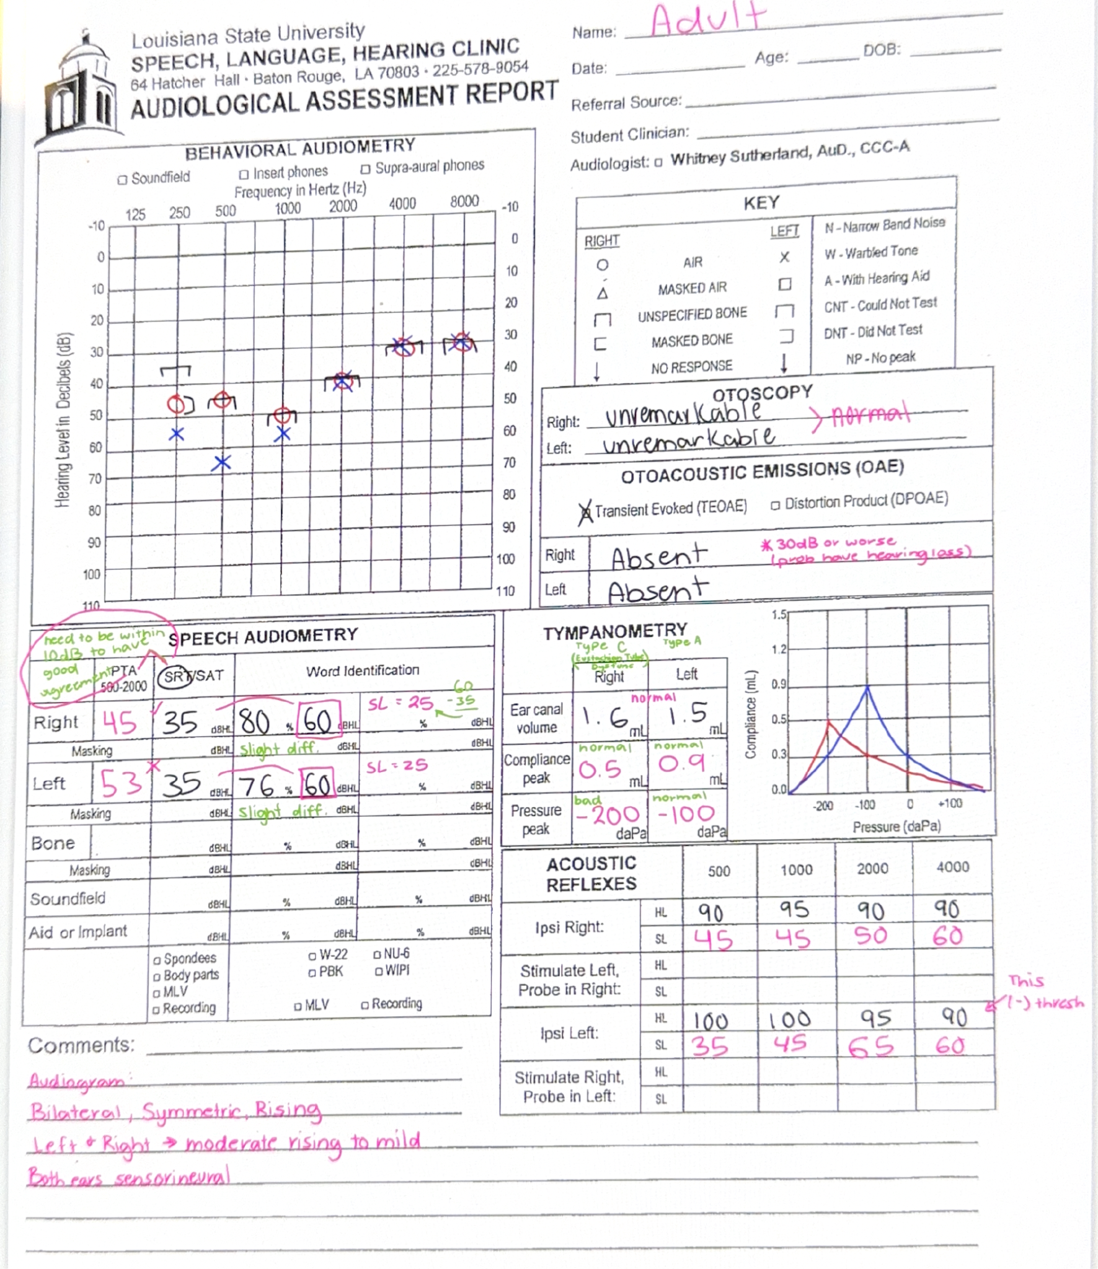
I didnt get to record her going over this one, sorry

